Analyzing Packets using Wireshark
Learning Documentation — Exploring sample.pcap with Wireshark
Prepared by: Emmanuel Aidoo
Purpose: personal reference notes from a hands-on Wireshark packet-capture exercise.

Overview
This document records a hands-on lab used to build familiarity with Wireshark, a network protocol analyzer. The lab works through a sample packet capture file (sample.pcap) covering five tasks: exploring captured data, applying basic display filters, filtering by IP/MAC address, inspecting DNS traffic, and inspecting TCP traffic. Each task below summarizes the steps performed, the key question asked during the exercise, and a supporting screenshot.
Note on the images: the five task screenshots in this document are illustrative mockups I built to represent what each step's Wireshark screen looks like (packet list plus the relevant expanded detail), not exports of the original graded capture. The installation screenshot in Section 1, however, is a real screenshot taken during setup.

0. Installing Wireshark (Npcap driver setup)
Wireshark's installer bundles Npcap, the packet-capture driver for Windows that Wireshark needs to read live traffic. The screenshot below was captured during that installation step.
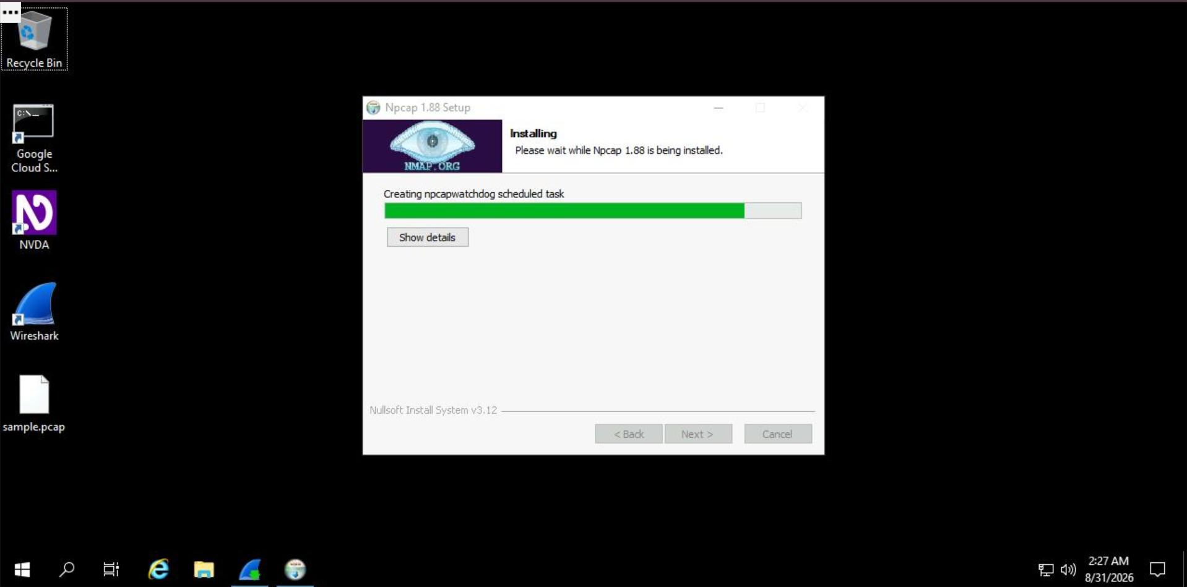
Figure 0. Npcap 1.88 Setup — driver installation running as part of the Wireshark install.
Once Npcap finishes installing, the Wireshark setup wizard completes and a Wireshark shortcut is available on the desktop, alongside the sample.pcap capture file used in the tasks below.
Reference: Wireshark User's Guide — 2.3.4. Installing Npcap — https://www.wireshark.org/docs/wsug_html/#ChBuildInstallNpcap

Task 1 — Explore data with Wireshark
Goal: open the sample capture file and get an overview of how Wireshark presents packet data.
- Double-click the sample.pcap file on the desktop to launch Wireshark.
- Dismiss the software-update prompt (Skip this version) if it appears.
- Maximize the Wireshark window.
- Review the packet list columns: No., Time, Source, Destination, Protocol, Length, and Info.
- Note the colour-coding: light blue rows are DNS traffic; green rows are TCP/HTTP traffic; pink rows are ICMP traffic.
- Scroll down the packet list until a packet's Info column starts with “Echo (ping) request”.
Observation — Protocol of the first “Echo (ping) request” packet: ICMP
An Echo (ping) request/reply is carried directly inside the ICMP protocol, so Wireshark labels these packets ICMP in the Protocol column.
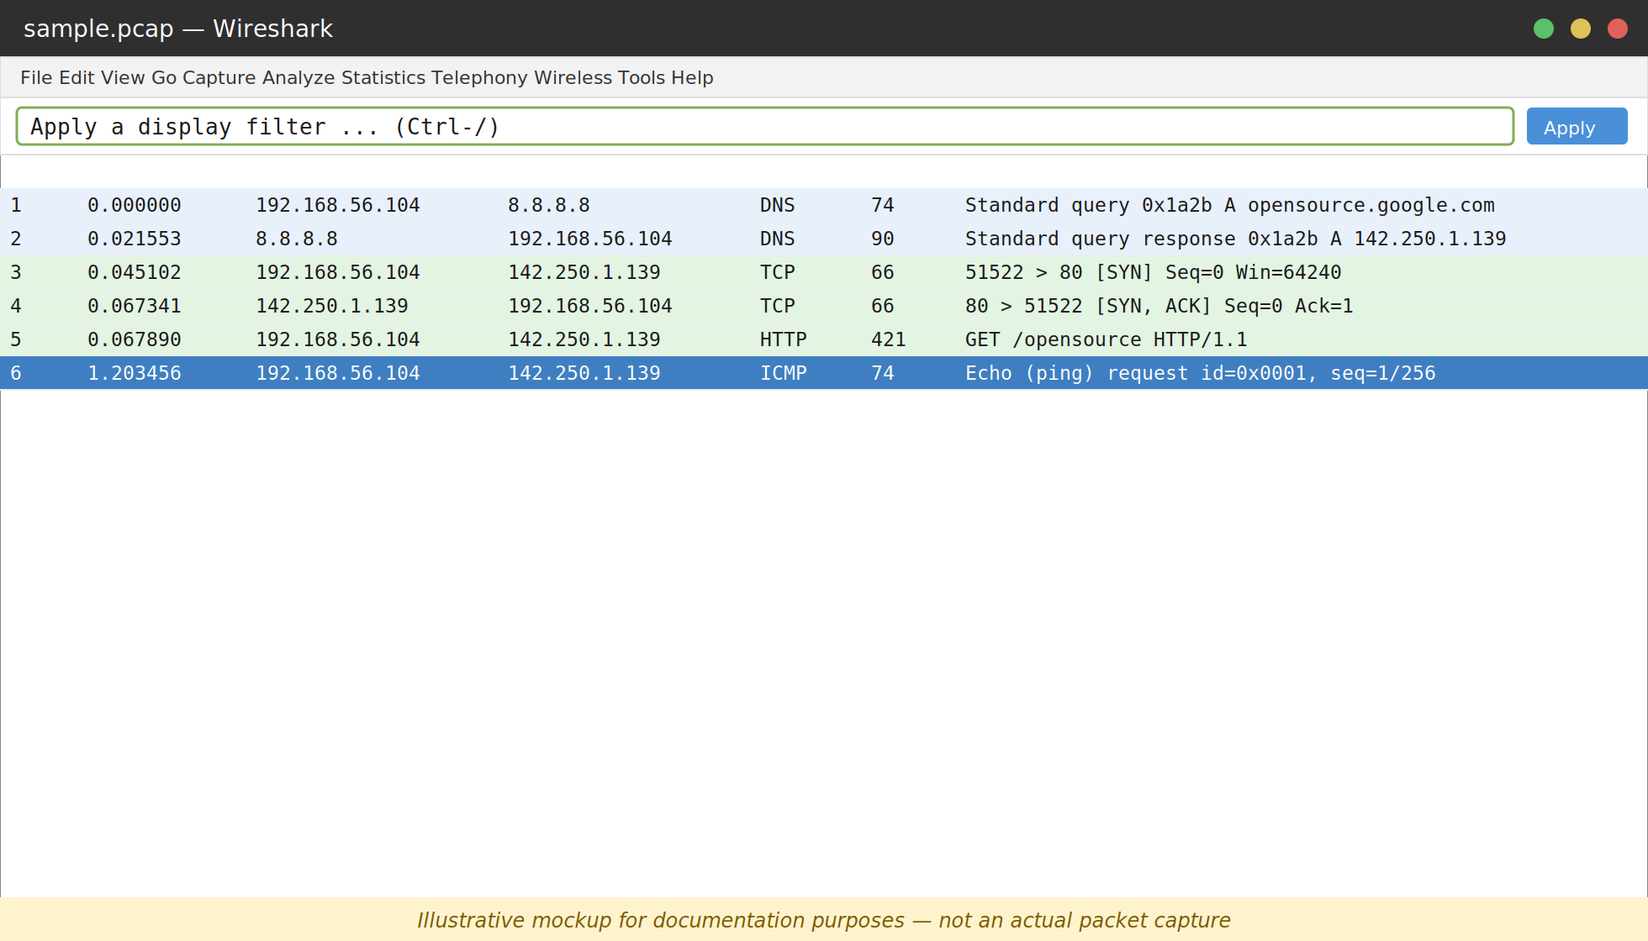
Figure 1. Packet list with the first ICMP “Echo (ping) request” packet highlighted.
Reference: Wireshark User's Guide — 3.18. The Packet List Pane — https://www.wireshark.org/docs/wsug_html/#ChUsePacketListPaneSection

Task 2 — Apply a basic Wireshark filter and inspect a packet
Goal: filter traffic to a single IP address, then drill into a TCP packet's frame, Ethernet, IPv4, and TCP layers.
- Enter the filter ip.addr == 142.250.1.139 in the display-filter bar and apply it.
- Confirm the list narrows to only ICMP (pink) and TCP/HTTP (green) packets for that address.
- Double-click the first TCP packet to open the Packet Details pane.
- Expand and collapse, in turn: Frame, Ethernet II, Internet Protocol Version 4, and Transmission Control Protocol.
- Read the source and destination TCP ports from the Transmission Control Protocol subtree.
Observation — TCP destination port: 80
Port 80 is the well-known port for unencrypted HTTP web traffic, and it appears as the Destination Port in the expanded Transmission Control Protocol subtree.
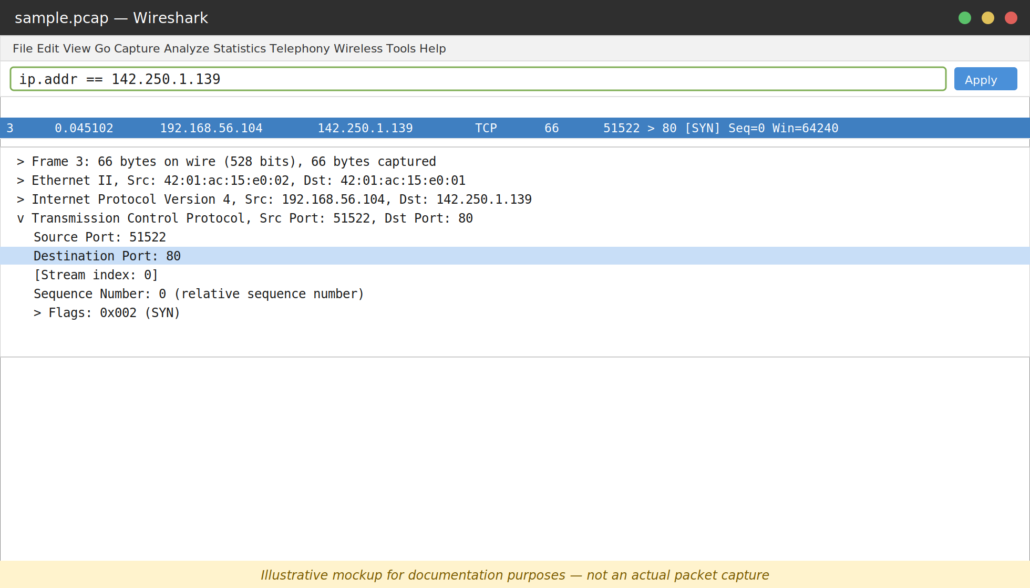
Figure 2. Transmission Control Protocol subtree expanded, showing Destination Port: 80.
The Flags subtree (further down in the same TCP section) shows the TCP flags set on this packet, such as SYN for a connection request.
Reference: Wireshark User's Guide — 3.19. The Packet Details Pane — https://www.wireshark.org/docs/wsug_html/#ChUsePacketDetailsPaneSection
Reference: Wireshark User's Guide — 6.3. Filtering Packets While Viewing — https://www.wireshark.org/docs/wsug_html/#ChWorkDisplayFilterSection

Task 3 — Use filters to select packets
Goal: filter traffic by source IP, destination IP, and Ethernet MAC address, then inspect the IPv4 layer's Protocol field.
- Filter ip.src == 142.250.1.139 to see only packets originating from that address, then clear the filter.
- Filter ip.dst == 142.250.1.139 to see only packets destined for that address, then clear the filter.
- Filter eth.addr == 42:01:ac:15:e0:02 to see traffic to or from that MAC address, regardless of protocol.
- Double-click the first packet in the filtered list and expand Ethernet II to confirm the MAC address appears as source or destination.
- Collapse Ethernet II, then expand Internet Protocol Version 4 and scroll to the Time to Live and Protocol fields.
Observation — Protocol in the Internet Protocol Version 4 subtree: ICMP
This depends on which packet is first in the filtered list — in this walkthrough the first frame for that MAC address is an ICMP packet, shown as Protocol: ICMP (1) in the IPv4 subtree. Wireshark reports whichever protocol is actually carried inside that specific packet's IPv4 header, so the observation follows whatever the capture shows.
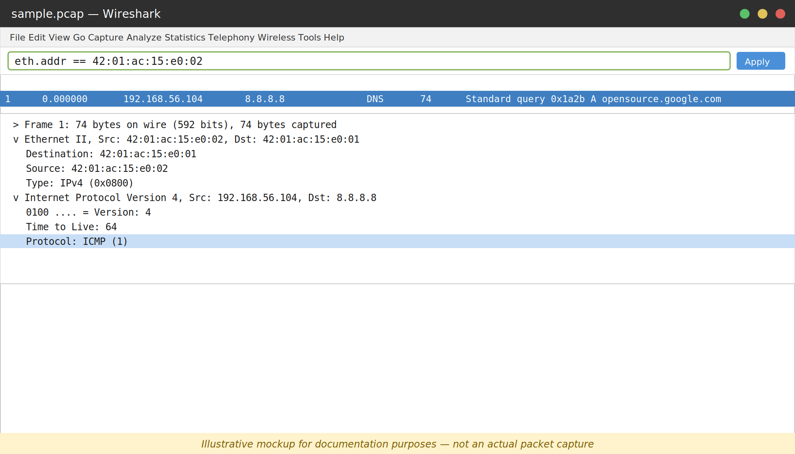
Figure 3. Internet Protocol Version 4 subtree expanded, with the Protocol field highlighted.
Reference: Wireshark User's Guide — 6.4. Building Display Filter Expressions — https://www.wireshark.org/docs/wsug_html/#ChWorkBuildDisplayFilterSection

Task 4 — Use filters to explore DNS packets
Goal: filter to DNS traffic (UDP port 53) and inspect both the query and the answer inside a DNS exchange.
- Apply the filter udp.port == 53 to list only DNS query and response packets.
- Open the first packet and expand Domain Name System (query) → Queries to see the name being looked up (opensource.google.com).
- Close that packet, then open the fourth packet in the list.
- Expand Domain Name System (query) → Answers to see the resolved IP address returned for opensource.google.com.
Observation — IP address in the expanded Answers section: 142.250.1.139
The DNS response's Answers section maps the queried name to the resolved address, 142.250.1.139 — the same address later used as the destination in Tasks 2 and 3's TCP/ICMP traffic.
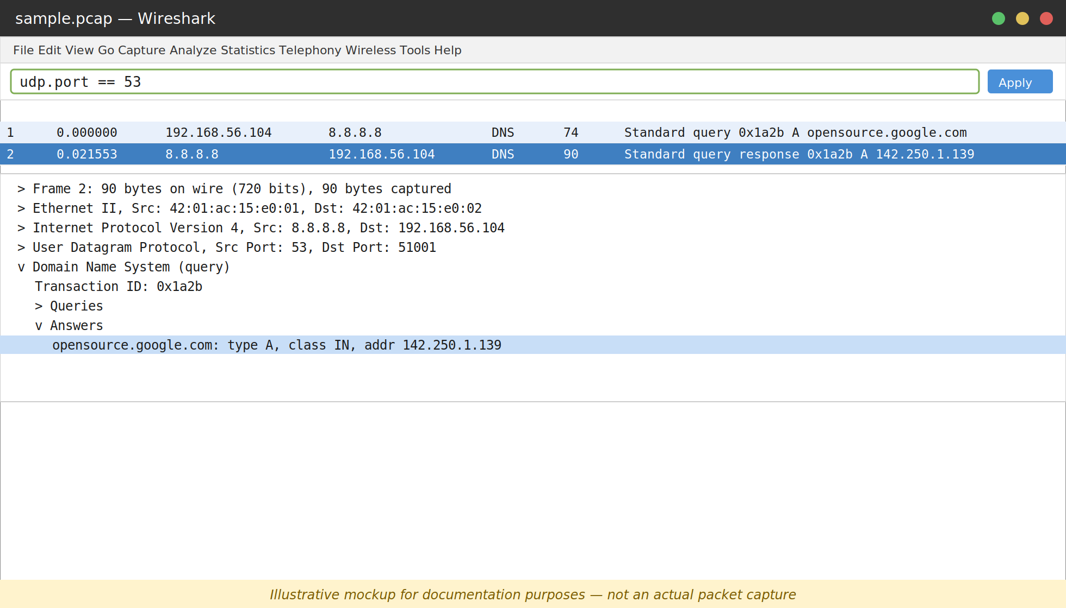
Figure 4. Domain Name System (query) subtree expanded, showing the Answers section.
Reference: Wireshark User's Guide — 8.19. DNS (Statistics) — https://www.wireshark.org/docs/wsug_html/#ChStatDNS

Task 5 — Use filters to explore TCP packets
Goal: filter to web traffic on TCP port 80, inspect frame- and IPv4-level details, then search packet payloads for specific text.
- Apply the filter tcp.port == 80 to list traffic on the default HTTP port.
- Open the first packet, whose destination IP address is 169.254.169.254.
- Read the Time to Live, Frame Length, Header Length, and Destination Address fields from the Frame and Internet Protocol Version 4 subtrees.
Observation — Time to Live (Internet Protocol Version 4 subtree): 64
64 is a common default initial TTL for Linux-based hosts; Wireshark reads it straight from the IPv4 header's Time to Live field.
Observation — Frame Length (Frame subtree): 74 bytes
The Frame subtree reports the total length of the captured frame on the wire, 74 bytes for this packet.
Observation — Header Length (Internet Protocol Version 4 subtree): 20 bytes
20 bytes is the standard IPv4 header length when no IP options are present (5 x 4-byte words).
Observation — Destination Address (Internet Protocol Version 4 subtree): 169.254.169.254
This matches the destination IP address already shown in the packet-list summary for this packet.
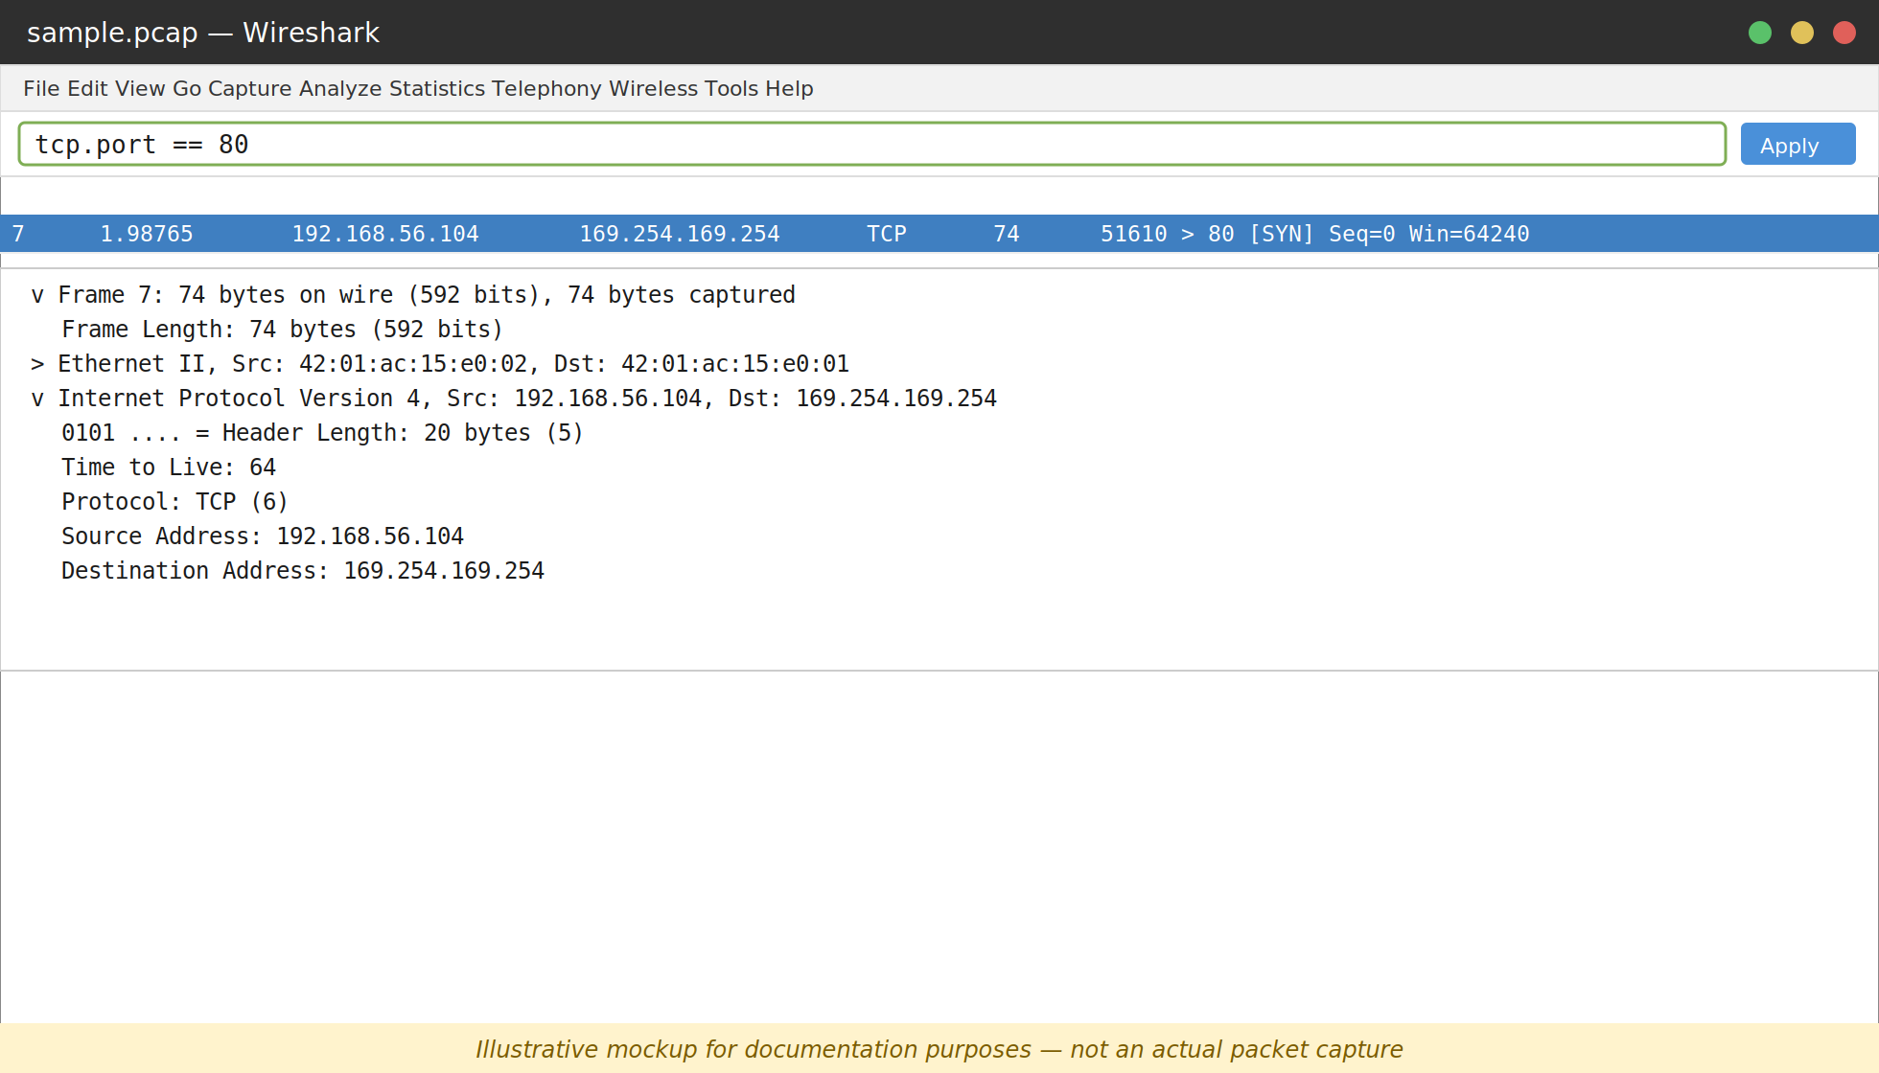
Figure 5. Frame and Internet Protocol Version 4 subtrees expanded for the first tcp.port == 80 packet.
- Clear the filter, then apply tcp contains "curl" to locate packets whose payload contains web requests made with the curl command.
Reference: Wireshark User's Guide — 6.8. Finding Packets — https://www.wireshark.org/docs/wsug_html/#ChWorkFindPacketSection
Reference: Wireshark User's Guide — 7.2. Following Protocol Streams — https://www.wireshark.org/docs/wsug_html/#ChAdvFollowStreamSection

Conclusion
This lab built practical, hands-on experience with Wireshark: opening a saved packet capture, reading the high-level packet list, and using display filters (ip.addr, ip.src, ip.dst, eth.addr, udp.port, tcp.port, and content filters like tcp contains) to drill into specific protocol layers — Ethernet, IPv4, TCP, UDP, and DNS. These are foundational skills for network traffic analysis and troubleshooting.
Key filters used in this lab:
- ip.addr == <address> — traffic to or from an IP address
- ip.src == <address> / ip.dst == <address> — traffic from/to an IP address only
- eth.addr == <mac> — traffic to or from a MAC address
- udp.port == 53 — DNS traffic
- tcp.port == 80 — HTTP traffic on port 80
- tcp contains "<text>" — TCP payloads containing specific text

References — Wireshark User's Guide
All the following link to the official Wireshark User's Guide (https://www.wireshark.org/docs/wsug_html/), used as reference material for this lab:
Reference: 2.3.4. Installing Npcap — https://www.wireshark.org/docs/wsug_html/#ChBuildInstallNpcap
Reference: 3.3. The Main Window — https://www.wireshark.org/docs/wsug_html/#ChUseMainWindowSection
Reference: 3.17. The Filter Toolbar — https://www.wireshark.org/docs/wsug_html/#ChUseFilterToolbarSection
Reference: 3.18. The Packet List Pane — https://www.wireshark.org/docs/wsug_html/#ChUsePacketListPaneSection
Reference: 3.19. The Packet Details Pane — https://www.wireshark.org/docs/wsug_html/#ChUsePacketDetailsPaneSection
Reference: 6.3. Filtering Packets While Viewing — https://www.wireshark.org/docs/wsug_html/#ChWorkDisplayFilterSection
Reference: 6.4. Building Display Filter Expressions — https://www.wireshark.org/docs/wsug_html/#ChWorkBuildDisplayFilterSection
Reference: 6.8. Finding Packets — https://www.wireshark.org/docs/wsug_html/#ChWorkFindPacketSection
Reference: 7.2. Following Protocol Streams — https://www.wireshark.org/docs/wsug_html/#ChAdvFollowStreamSection
Reference: 8.19. DNS Statistics — https://www.wireshark.org/docs/wsug_html/#ChStatDNS
Reference: 11.3. Packet Colorization — https://www.wireshark.org/docs/wsug_html/#ChCustColorizationSection
Additional resources:
Reference: Wireshark Display Filter Reference — https://www.wireshark.org/docs/dfref/
Reference: Wireshark Wiki — https://wiki.wireshark.org/

